See This Article: Comparing PM Certifications
Posted on Monday, July 15th, 2013 at 5:15 pm.

Which project and programme management certifications are best for you? Learn how the Certification Effectiveness Cube helps you make better-informed decisions. This analysis is based on a range of published studies and reports. We offer a fresh new analysis to help balance misinformed impressions seen elsewhere on the web.
Written by Stacy Goff, principal of ProjectExperts, a global project and programme management consulting firm, the article is available from the Thought Leaders page, in the IPMA Resources section of this website. Below are a few of the highlights from the article.
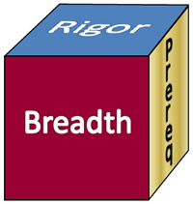The Certification Effectiveness Cube is a representation of three factors that are important in evaluating any certification:
A. Prerequisites
B. Breadth of Coverage
C. Rigor of Assessment
The article explores those three factors, or criteria, and acknowledges that popularity is also an important consideration; it reveals an interesting relationship between popularity and effectiveness.
A. Prerequisites are important. They help assure that a certification is targeted at the right qualified persons. See below a comparison of PM-related certification program prerequisites, based on a study by Dr. Paul Giammalvo.
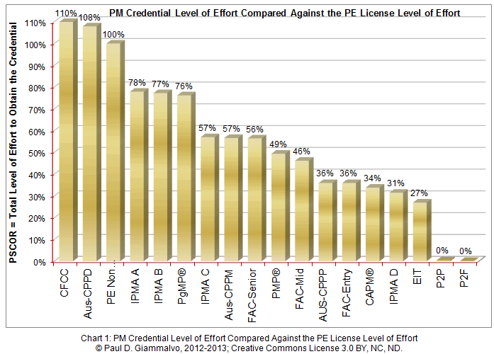
B. The second factor considered in the article is the Breadth of Coverage. See the diagram below, comparing the coverage of a variety of project management standards, based on a GAPPS study. As other organizations have come to understand that the “triple constraint” has been long-dead, and that business savvy and leadership & interpersonal skills have some of the greatest impact on project success, just look at the chart. When someone asks you “Are you ready?” The chart shows Who Is Ready Now!
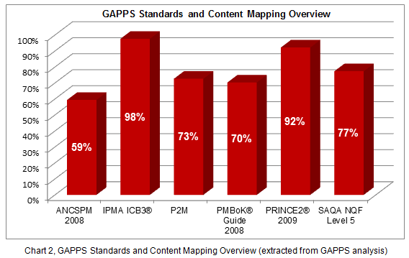
C. And the Rigor of Assessment is the third factor, or criterion, considered in the article. This factor is also based on a GAPPS study, and includes degree programs and other comparisons. Why is this Rigor important? Because knowledge alone, while an important foundation, is merely a starting point. And if it is only acquired for the purposes of passing a multiple-choice exam, it soon decays–the half-life of knowledge acquired, but not-applied is said to be two weeks.
That knowledge must be applied (moving towards Skill), added to the interpersonal skills needed to engage others in its application (Behavioral competences), and adapted in multiple settings (practical experience) to get needed business results. Certifications with higher Rigor scores assess more of the full life-cycle of that knowledge, from short-term acquisition to business results.
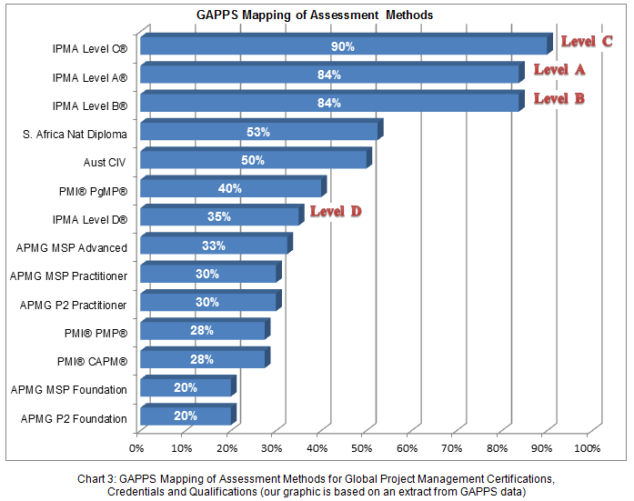

Which Certifications Win?
There are several ways of answering this question, depending on your requirements. What is most interesting about analyzing the outcomes of these three independent studies is what happens when we cross-multiply the three studies’ results. Chart 4 below shows the results of cross-multiplying the volume of the Certification Effectiveness Cube. But your requirements may show a different result. We leave the decision up to you.
Regardless of your outcome, you are the winner when PPM certification candidates—and their managers and executives—can see the relative strengths of today’s leading PPM certifications. And, when you win, the practice of effective project and programme management wins.
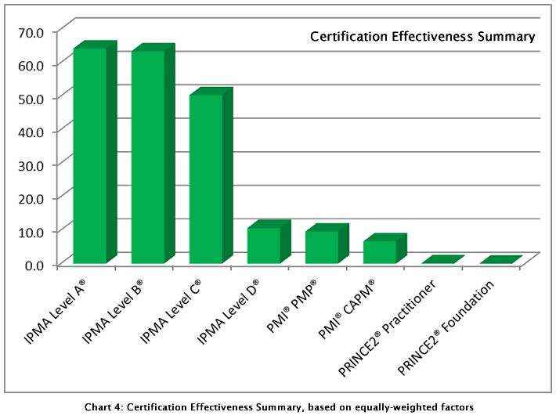
After all, that is the basis of our Certification Effectiveness Cube: We are looking for not a single point of evaluation (a common situation on popular websites), or even two points: We are looking for all three points, to assess the volume of certification effectiveness.
See the full article, Comparing PM Certifications, for the “The Cube’s” descriptions of the PM certification effectiveness factors of popular global offerings. The article also has more details and links for each of the studies, so you can draw your own conclusions.

Note: In addition to his Project and Programme Management consulting practice, Goff is also IPMA VP of Marketing & Events, and President of asapm, IPMA-USA.
All trademarks are the property of their registered owners.
Home / News / See This Article: Comparing PM Certifications

Recent Posts
- About Our Blogs and Commentaries
- Efficiency & Effectiveness in Project Management
- Navigating the S’s in Our Projects
- Project Management: Delivering The Promise
- Exposing the Myth of “Doing More With Less”

Resources
- The IPMA News Section
- About Our Blogs and Commentaries
- IPMA Events
- Jouko Vaskimo Reports on 27th IPMA World Congress
- What Our IPMA Excellence Award Winners Say…
Read More
- IPMA, P.O. Box 1167, 3860, BD Nijkerk, The Netherlands
- Tel.: +31 33 247 3430
- Fax: +31

